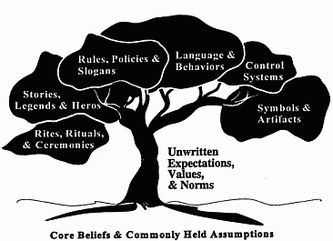
List the Top 3-5 Cultural Culture
Norms for Cats and Dogs
Language
-theirs
-ours
Behavior
Rules (house)
Rituals (habits)
Stories/Legends/Heroes/Myths
Symbols

